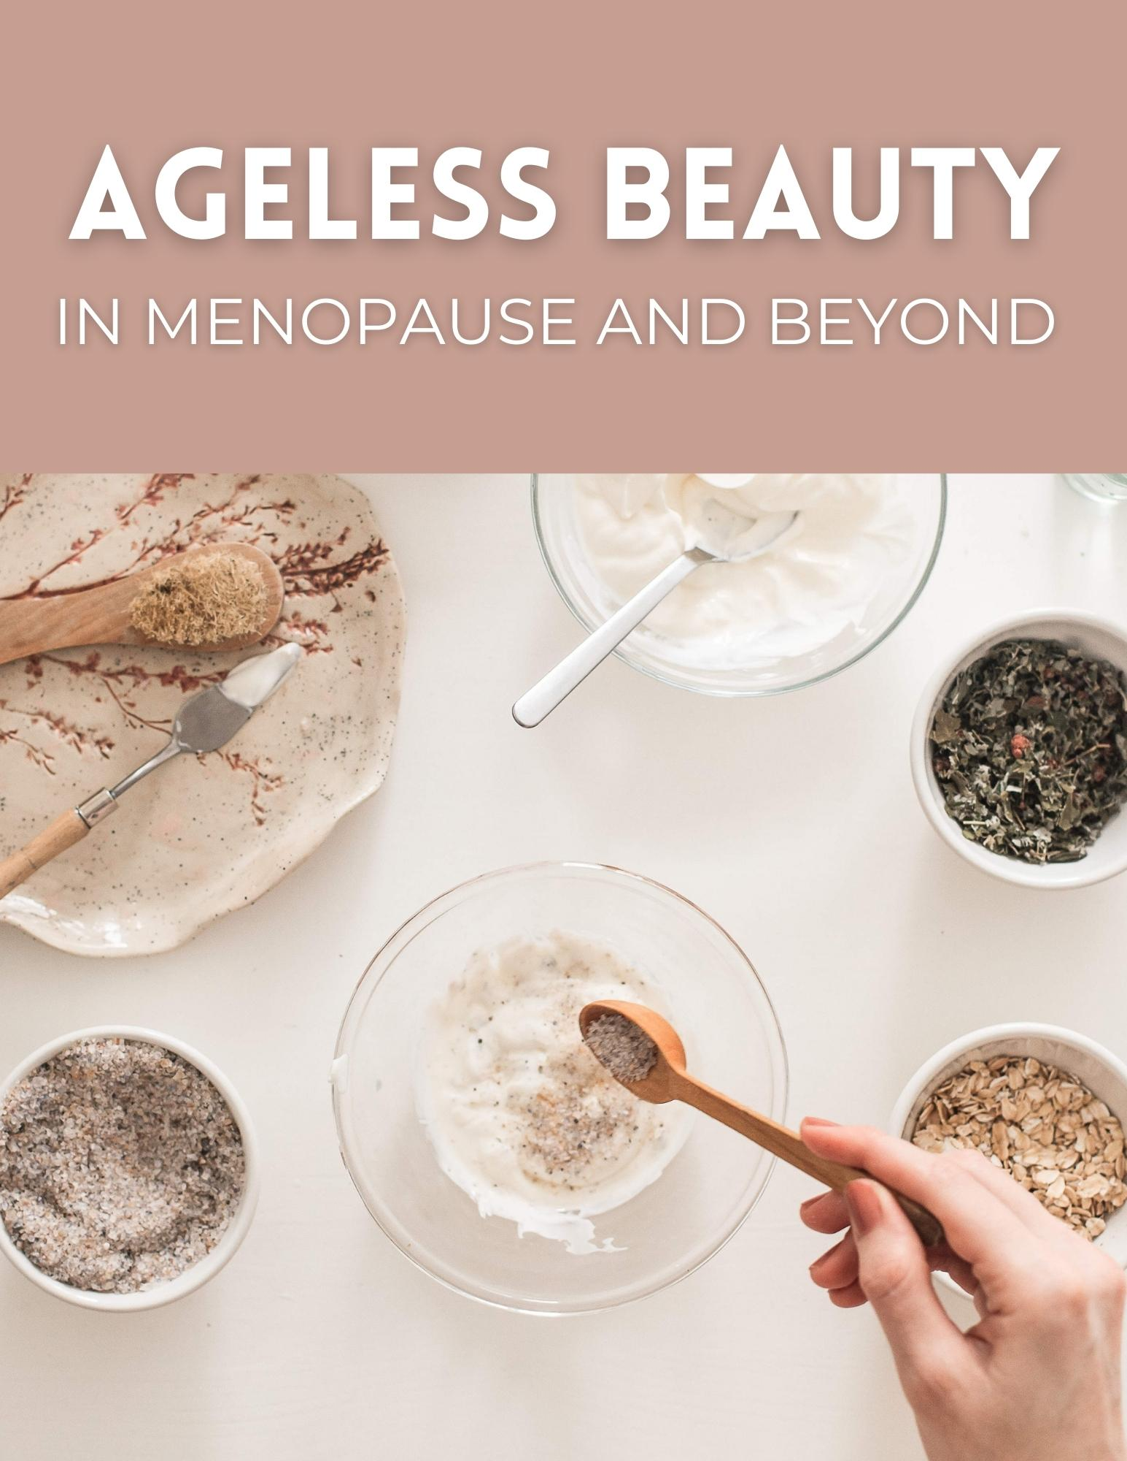

DISCLAIMER:
This guide was written by CAT DILLON,RHN, I am not a doctor or mental health professional and cannot be held liable for the information written here.

This guide is meant to provide educational information only. For medical assistance, please seek help from a medical or mental health professional.

Contents

INTRODUCTION 4
The following are some of the skin changes you might experience after menopause and what you can do to manage them. 4
HOT FLUSHES 4
What you can do: 4
OILY SKIN OR ADULT ACNE 5
If your skin is abnormally oily, look for organic skincare with: 5
EXCESS FACIAL HAIR 6
What you can do: 6
LOOSE SKIN AND WRINKLES 6
What you can do: 6
THINNING SKIN, SLOWER CELL TURN OVER AND REDUCED BARRIER FUNCTION 7
What you can do: 7
SUN DAMAGE 8
What you can do: 8
HYPERPIGMENTATION OR AGE SPOTS 8
What to do: 9

INTRODUCTION
Menopause is something that every woman naturally goes through. It is marked by the end of the monthly cycle, and for some women, this is all there is to it. However, for others, it is the beginning of a challenging process that can last for several years, bringing a lot of changes with it. Leading up to menopause, ovarian activity gradually slows down before stopping completely, and the actions of your sex hormones also decline. The decline of B-Estradiol is the number one cause of the accelerated aging of the skin that occurs after menopause. The good news? There’s a lot you can do to keep your skin healthy and glowing during menopause and beyond!

The following are some of the skin changes you might experience after menopause and what you can do to manage them.

HOT FLUSHES
Among the things that these hormonal changes can cause are hot flushes. Hot flushes are intense feelings of warmth within the skin. They cause embarrassing redness in the skin of the face and may even cause perfuse sweating.

What you can do:
- Reduce Caffeine Intake – Very stimulating.
- Dandelion root, red clover and motherwort herbs - These are my go-to herbs for flushing and sweating. You can make them into herbal iced tea.
- Bio-Identical Progesterone Cream – You can purchase progesterone cream over the counter. You get what you pay for, so read labels.
- Herbal Phytoestrogen Formula – There are lots of good ones out there. Be sure to avoid products with processed soy protein isolates.
- Cooling facial mists – Make a mist with lavender and rose hydrosol.
- Avoid hot showers – Do not allow yourself to get overheated.
- Manage stress – Techniques such as deep breathing, meditation, and grounding exercises, which can help calm the mind and bring a sense of peace and balance to our lives.
- Hormone Detox – Supports healthy estrogen metabolism.

OILY SKIN OR ADULT ACNE
B-Estradiol stimulates sebaceous gland secretions or the anti-acne effect. As you approach menopause, you experience a reduction in estrogen production, which means the testosterone that is produced by the adrenal glands is no longer getting masked in your body. Testosterone gets the sebaceous glands to produce thicker sebum, resulting in oily skin and even adult acne in some women.

If your skin is abnormally oily, look for organic skincare with:
- ​Salicylic Acid - A type of Beta Hydroxy Acid. Salicylic acid comes from white willow bark.
- ​Sulfur - A natural ingredient that absorbs oil and has a mildly antibacterial action.
- Glycolic Acid - A type of Alpha Hydroxy Acid derived from sugar cane. Glycolic acid is an excellent skin exfoliator.
- ​Natural clays - Clay draws out toxins, bacteria, and extra oil from the pores.
- ​Hyaluronic Acid - Hyaluronic acid is ​an ideal moisturizing agent for oily skin.
- ​Vitamin C – Potent antioxidant.

EXCESS FACIAL HAIR
This is also as a result of the unmasking of testosterone. Some women develop facial hair particularly in the areas of the chin.

What you can do:
- Waxing
- Threading
- Electrolysis
- Laser treatment
- If severe, you can purchase anti-androgen herbal supplements that contain herbs such as black cohosh, chaste berry and licorice root.

LOOSE SKIN AND WRINKLES
Estrogen is responsible for stimulating fat deposits in the female body. When the levels of estrogen drop, fat deposits get redistributed and deposited in specific areas, mostly concentrating around the abdomen, thighs, and rear end. This causes a loss of fat below the skin in the rest of the body, especially the face, neck, and arms. Loose skin and wrinkles then appear in those areas as the skin becomes less easily compressed and loses its mobility. This is also the reason why the breasts lose firmness.

What you can do:
- Do not smoke or drink alcohol.
- Eat healthfully and boost your healthy fats.
- Consume natural phytoestrogens from whole foods such as seeds, legumes, and organic soybeans.
- Use collagen and gelatin supplements.
- High-dose vitamin C for extra collagen boost.
- Exfoliation is key.
- Keep the skin hydrated.
- Get professional facials with pressure point therapy and lymph drainage.
- Use firming creams with protein peptides and seaweeds.

THINNING SKIN, SLOWER CELL TURN OVER AND REDUCED BARRIER FUNCTION
Another function that estrogen plays in the female body is the growth and maintenance of blood capillaries in the dermis. When estrogen levels drop, blood flow through the capillaries in the dermis also drops. This means fewer nutrients and oxygen will be availed to that area. The result is the thinning of the epidermis, a slower cell turnover rate and a reduction in the barrier function of the epidermis. When this happens, you will also experience trans epidermal water loss and dry skin.

What you can do:
- Herbal Phytoestrogen Formula – There are lots of good ones out there. Be sure to avoid products with processed soy protein isolates.
- Bio-Identical Progesterone Cream or DHEA cream – You can purchase these over the counter. You get what you pay for so read labels.
- Broad-Spectrum Multi-Vitamin: High potency!
- Seed Cycling: Yes, this really does help boost estrogen!
- High-quality facial moisturizer for mature skin: Look a natural formula that has peptides and other antiaging ingredients.
- Reduce Coffee Intake – Too astringent for mature skin.

SUN DAMAGE
Estrogen also maintains Melanocytes, which are the cells that manufacture melanin. When estrogen levels drop, melanocytes begin to degenerate, leaving you with fewer of them. The skin will then appear lighter and become more prone to sun damage due to the lower amount of melanin that you have.

What you can do:
- Use a good sunscreen.
- Always wear a hat and sunglasses when outdoors.
- Vitamin C or Glutathione creams are excellent as they offer a boost of antioxidants.
- Creams with essential oils such as frankincense and rose to boost your cell renewal factor.

HYPERPIGMENTATION OR AGE SPOTS
Besides maintaining your melanocytes, estrogen also regulates the amount of melanin that can be produced at any one time. When menopause arrives and the production of estrogen drops, the areas of the skin that have been hit by UV rays the most over the years’ experience more melanin synthesis. Sun damage results in brown age spots on the hands, face, neck, arms, and chest in some women.

What to do:
- Glycolic acid - A type of Alpha Hydroxy Acid derived from sugar cane. Glycolic acid is an excellent skin exfoliator.
- Vitamin C or Glutathione creams – A good antioxidant.
- Skin brightening creams – Natural creams with zinc, Oligopeptides, algae and other skin lighteners.
- Exfoliation – Boosts your cell renewal factor.
- Herbal formulas for liver support – cleansing the liver can help a lot.
- Juicing – Especially green juices.

CONCLUSION
It is important also to mention here that the cells that make up the skin surface are quite like the cells that make up the urinary tract and the vagina. This means that when you notice changes in the skin, such as its wrinkling, sagging, drying, and loss of resiliency, similar changes are probably happening in the urinary tract and the vagina. In this way, the skin can be an essential tool for revealing many tell-tale signs.

HELPFUL LINKS FOR WHAT I USE
Beauty Counter Antiaging Herbal, Antioxidant and Vitamin C Serums, Sunscreens and Safer Skin Care and Cosmetics
Greens Powders from Dr. Cowan’s Garden
C60 Antioxidant Oils
Essential Oils

